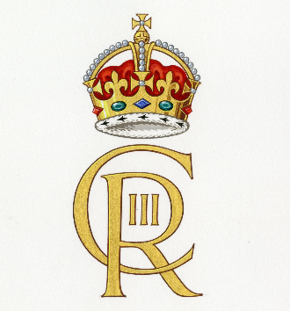
Coronation Celebrations
On Saturday 6th May the coronation of their majesties King Charles III and Queen Camilla will take place at Westminster Abbey. To celebrate this occasion in school we have arranged the following events for the children.
Friday 5th May
This will be non-uniform day- the children can come to school dressed in red, white or blue or a combination of colours. We will have a fun packed coronation themed morning where the children will take part in a range of activities in their buddy groups.
“Street Party lunch”
We will serve a special coronation packed lunch instead of the usual lunch menu on this day, hopefully the weather will be kind to us so we can hold it outside in the school field.
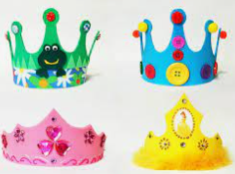
Design Your Own Crown Competition
To mark this special occasion the children are asked to design and make their own crown at home to wear on Friday 5th May. There will be a prize for the most imaginative crown for each year group. There will be a crown procession at school pick up time so parents can see all the fantastic creations.
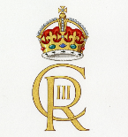
Design a Coronation poster
The children will be designing a poster in school to celebrate the coronation. Whittonstall Community Group will display them in the church for their coronation picnic event. They will judge the winning poster for each class and award them a certificate.

