 | Whittonstall and Broomley First Schools  Weekly Newsletter  17 September 2021 | 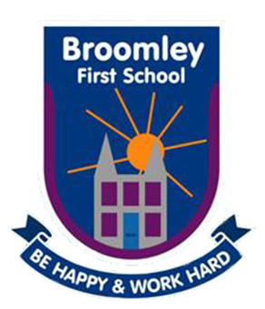
Tel: W: 01207560325 B: 01661842271 Website:www.broomley.northumberland.sch.uk/website
________________________________________________________________________

Our overall attendance this week was
91.3%
_____________________________________________________________________________

HEAD TEACHER’S MESSAGE:
A huge well done to all the children for fantastic effort on the ‘Doodle Learn’ platform for homework this week. As you will know the children took part in a baseline assessment when setting up the new system, this then ensures that the questions and activities are linked to the children’s individual strengths and areas for development. The teachers are able to analyse effort, understanding and progress and will be able to share this with you at the up and coming parents evenings. As a parent you are also able to download the ‘Doodle connect app’ with lots of information on how you can use the information at home. If you visit https://www.doodlelearning.com/parent-webinars there two really useful videos where you will learn about the doodle products, how the apps work from a child's perspective, how you can monitor and support your child, and how to get help with Doodle. The expectation for the children is little and often so 10 minutes of independent time each day at home will ensure gaps in learning are tackled and the children become more confident in approaching concepts they find difficult.

As we have returned to school, as expected, the number of coughs, colds and potential Covid cases has risen. We have had confirmed Covid cases in both our schools this week and will continue to follow the advice of public health when dealing with any potential outbreaks. NHS track and trace have taken over identifying close contacts with individual cases. If your child has been in close contact with a positive case they will contact you directly for any further action you should take. We will continue to err on the side of caution and if your child is displaying symptoms in school, we will contact you to ask you to seek advice from 119. We are aware this can often be an inconvenience to parents although we must insist on following these procedures to keep levels of transmission under control. We have reintroduced face covering this week into school for staff and we are continuing our testing programme as well as many staff taking PCR tests this week too. We appreciate parents who have been wearing masks on drop off and collection, although we realise this can not be enforced, we are grateful for everyone playing their part in keeping our school community safe. If there is anything you are worried about or would like to discuss further please feel free to contact Mrs Barker.
__________________________________________________________________
AWARDS OF THE WEEK:

Nursery Bucket Filler of the Week: Maisie Dickinson for such super chat and listening!

Kid Awesome - Stars of the Week:

Class 1 Charlotte Turnbull for marvellous maths
Class 2 Martha Craig and Nathan King for their amazing Andy Warhol inspired toy art
Class 3 Woody Armstrong for his excellent mathematics, finding all the combinations.

_______________________________________________________________________

SCHOOL UPDATES
School Photos: Debbie Young Photography is coming into school next Tuesday 28th September to take individual and sibling photographs of the children. We will arrange for all siblings in school and nursery to have pictures taken together so you do not need to request this. Each child will have their own password protected file on the Debbie Young website that parents will be able to access. You will be able to view the photographs and order and pay online. Photographs will then be delivered to school for your child to bring home.

Whittonstall Autumn Fair Saturday 2nd October 12.00 - 2.00 pm: We are really looking forward to our Autumn fair on Saturday 2nd October, organised by The Friends of Whittonstall First School. It will be held on our community field here at the school and there will be lots to see and do, including bouncy castle, traditional fair games, craft stalls, face painting, hot food, drinks and treats. In order to support the fair, just a reminder that we would be most grateful if our families were able to make some donations, which can be sent in to school with the children or dropped off at the start and end of the day -

● Class 1 - we would love it if you could support our ‘chocolate and sweet treat’ stall. Any donations of chocolates or sweets are very welcome.
● Class 2 - any items for our ‘pamper’ stall would be gratefully received e.g. toiletries, soaps and beauty products.
● Class 3 - we would like you to support our ‘bottles and jars’ stall. Donations are welcomed of anything which would come in a bottle or jar e.g. wine, bubble bath, condiments, sauces etc

The children have been sent home with a colouring competition sheet for the fair. If they would like to take part could you please return their coloured sheet along with a 50p donation, making sure you write your child’s name on the back.

Fabulous French Day- Friday 8th October: Bonjour!
On Friday 8th October 2021 we will be holding a whole school Fabulous French Day celebration. Your child is invited to come to school dressed up in the colours of the French flag as part of the fun. During the course of the day, children will have the opportunity to listen to stories in French, taste French food, paint in the style of a famous French artist and immerse themselves in exciting French themed activities in their classes. There will also be an optional opportunity for all children to visit our popup French Café during the day and buy a crêpe, croissant or pain-au-chocolate to eat. There will be a charge of £1 for those who would like to do this.We are looking forward to a fun filled celebration with your child.
À bientôt mes amis! Madame Humes

Outdoor Toddler Sessions:

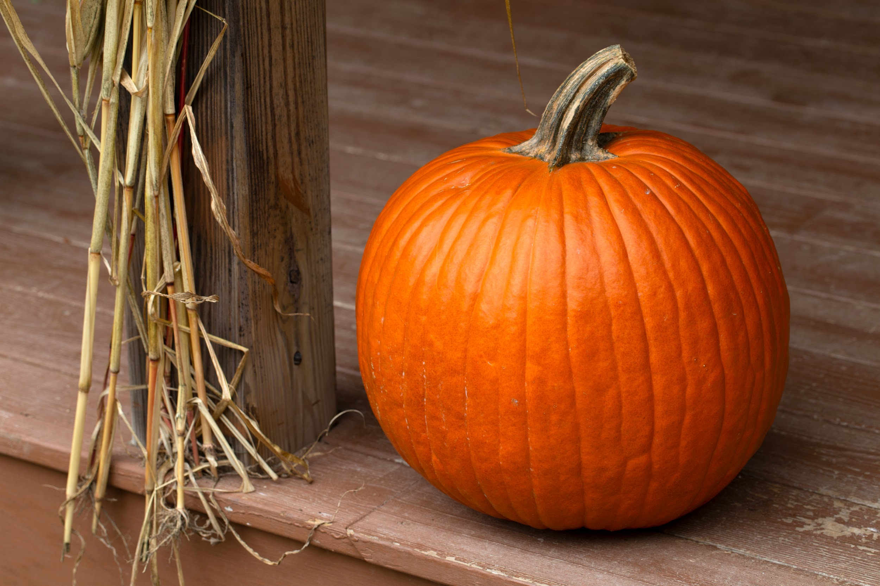
Our outdoor learning teacher Miss Richardson will be holding some toddler outdoor sessions on the community field on the following dates -

Thursday 7th October - Celebrating all things autumn

Thursday 21st October - Pumpkin and Apple Celebrations

Thursday 4th November - Bonfire Celebrations

Thursday 18th November - Wonderful Winter crafts

Thursday 2nd December - Advent celebrations

Thursday 16th December - Christmas Party in the Outdoors

The sessions will run from 9.15 to 11.15 am on the school field and all pre-school age children are welcome to come along. The children will enjoy hot chocolate and a snack (biscuits and fruit) and there will be a small charge to cover this and resources.

Macmillan Coffee Afternoon: thank you to everyone who came along to support our Macmillan coffee afternoon today. We will let you know how much we have raised in next week’s newsletter.

Driving in the village: Could we please make a polite reminder about considerate and safe driving and parking outside of school at pick up and drop off times. We have been asked to particularly stress the importance of taking care when turning vehicles on what can be a very congested road with limited visibility.Thank you for your help with this.

Y4 Application for Middle Schools - Portals now Open: It's that time of year again when the admissions portals open for the 2022 admissions round. The Portals are open for all Secondary, Middle and High School phase changes. The deadline for applications to middle schools is the 31st of October.
For families who pay their council tax to Durham County Council, please follow the link below

https://www.durham.gov.uk/article/2192/Apply-for-a-secondary-place-deadline-31-October-2020

For families who pay their council tax to Northumberland County Council please follow the link below –
https://www.northumberland.gov.uk/Education/Schools/School-admissions-places-appeals-1.aspx

Parents will be informed of the outcome of their application on Offer Day, Monday 1 st March 2021. For parents applying for a Reception class place for their child for September 2022, the portal will be open to apply between 1 st November 2021 and 15 th January 2022. Look out for more information in the newsletter nearer to the time. It is very important that applications are made on time. Any applications made after the deadline date will be treated as late and will be dealt with once all other applications have been processed. We have been sent information from Corbridge and Highfield Middle Schools about their upcoming events for Year 4 children, see below.

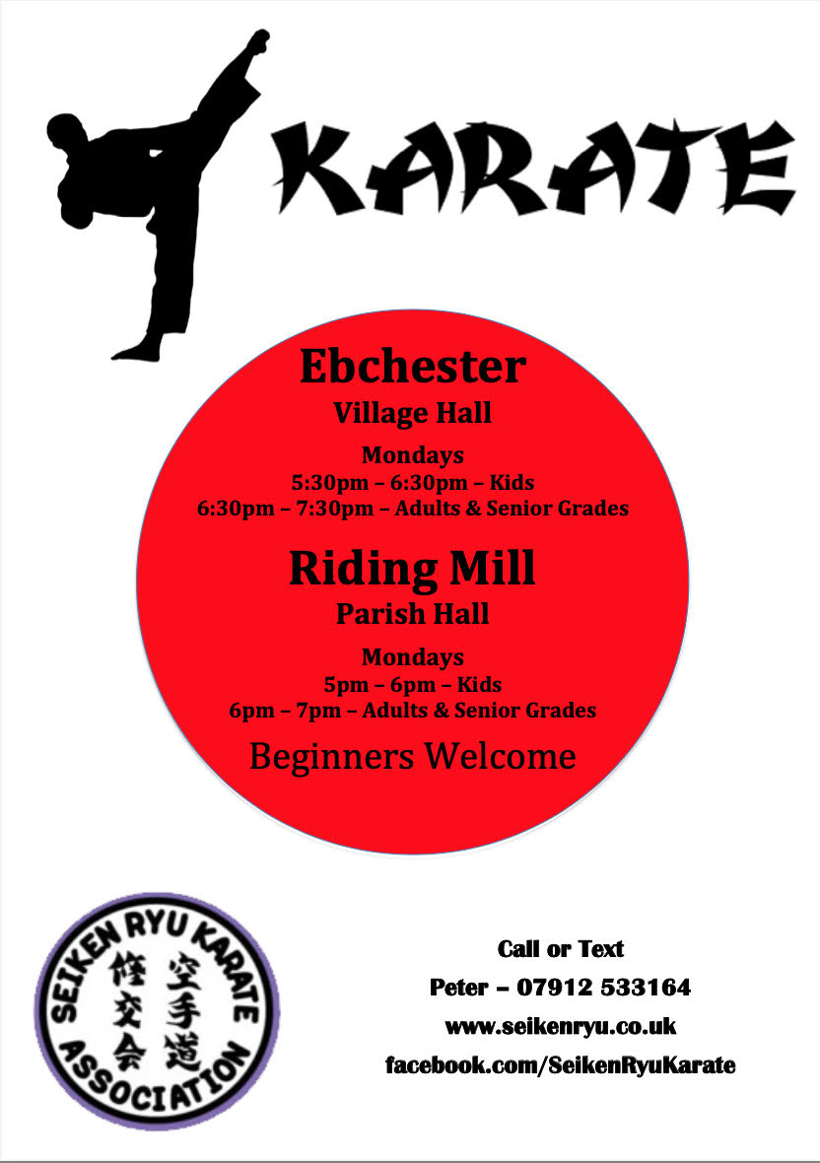
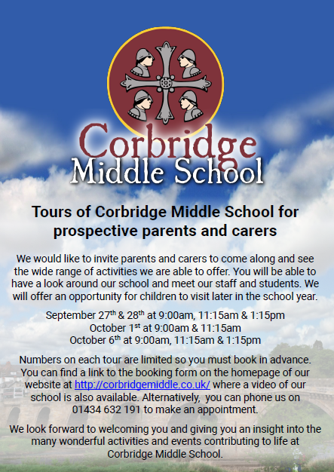
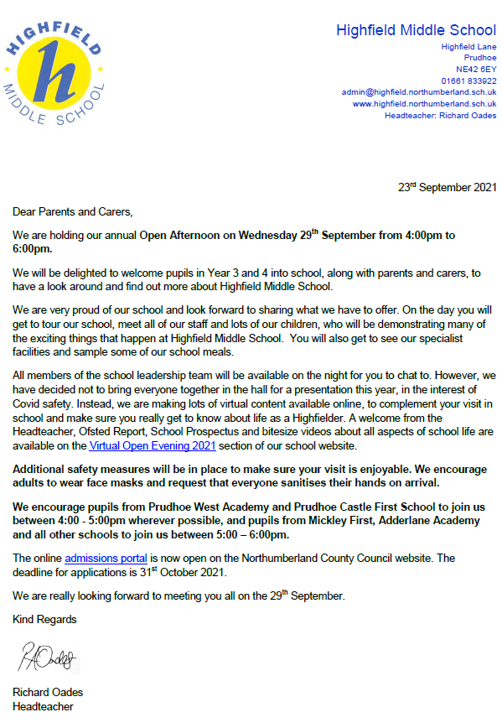

Things to Do:

DIARY DATES
- Saturday 2nd October 12.00 -2.00 Autumn Fair on Community Field
- Friday 8th October French Themed Day - see above for more details
- w/c 11 October Virtual Parents’ Evenings - dates and times to be confirmed
- Thursday 21st October Halloween Non Uniform Day - more information to follow
- Friday 22nd October Teacher Training Day
- Mon 25th - Fri 29th October Half Term
- Monday 1st November Return to school for Autumn 2
- Friday 5th November Bonfire Night Outdoor Day - more information to follow
- Wednesday 10th November Pamela Butchart Virtual Book Event - Y2
- w/c 29th November Interfaith week - more info about planned activities and trips to follow
- Friday 10th December Christmas Jumper Day for Save the Children
- Friday 17th December Class Christmas Party Afternoon
On behalf of staff and governors may I wish you all a lovely weekend, take care and stay safe.
Mrs Barker
Executive Head Teacher

