Communication and Language
Using stories, songs, roleplay and collaborative play opportunities the children will practise listening and responding appropriately to others. They will follow instructions in play and adult led tasks and talk about what they observe, likes and dislikes and why they think things happen.
Key Skills
- Extend vocabulary, especially by grouping and naming, exploring the meaning and sounds of new words.
- Respond to instructions involving a two-part sequence.
Personal, Social and Emotional
The children will work collaboratively in play and start to gain confidence to share resources, their ideas and thoughts with others. They will continue to develop understanding of how their actions affect others and how to be a good friend and ‘bucket filler’.
Key Skills
- Confidence to talk about self in positive terms and talk about abilities.
- Confidence to share ideas and opinions with others.
- Understand behavioural boundaries and how actions affect others.
Physical Development
The children will enjoy daily outdoor learning sessions and daily music and movement to develop strength, coordination and gross motor. They will explore the outdoors using a range of large apparatus to travel and construct for a purpose. They will use malleable materials and a range of tools to mark make and develop strength and accuracy in their fine motor control. Key Skills
- Experimenting with different ways of moving and travelling with skill.
- Form recognisable letters, most of which are correctly formed.

Literacy
Using stories, poems and rhymes on the animals/seasonal changes theme children will be encouraged to join in and identify rhyme in familiar stories, such as ‘Dear Zoo’ and ‘Elmer’ and discuss simple features such as characters and setting. They will play games that help them identify sounds in words and recognise letters and sounds around them in the setting.
Key Skills
- Continue a rhyming string.
- Begin to recognise letters of personal significance.
- Talk about stories they are familiar with.
- Enjoy an increasing range of books.

Mathematics
Play and adult led activities will develop number recognition, accurate counting (one to one correspondence), combining sets to find a total and comparing number. They will practically explore simple problems such as finding ‘one’ more or suggesting who has most/least.
Key Skills
- Use everyday language to talk about size, weight, capacity and money.
- Recognise numerals to 10 and use them accurately in play. Count up to 10 objects accurately.
- Combining groups to find a total.

Key Skills

Creative Curriculum
Animals and Seasonal
Change
2020 Autumn Term: Nursery
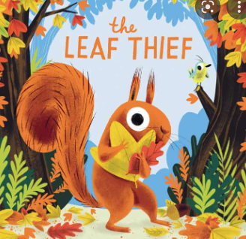

Expressive Arts and Design
Key Skills
- Construct with a purpose in mind
- Begin to build a repertoire of songs and dances, singing simple songs, tapping a beat, moving to music
- Use a variety of art tools with increasing accuracy to create using a variety of medias.

Understanding the world
Explore the world around them and how we are similar and different in
our likes, favourite things, appearance. Weekly outdoor
learning mornings will encourage children to explore their
environment and build new skills with an outdoor focus.
Share news regularly about their own lives and experiences
Key Skills
- Talk about past and present events
- Talk about similarities and differences
they observe in the world around them.

