 | Whittonstall and Broomley First Schools  Weekly Newsletter  6th May 2022 | 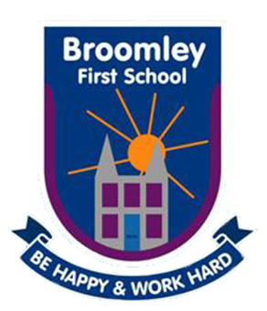
Tel: W: 01207560325 B: 01661842271 Website:www.broomley.northumberland.sch.uk/website

TODAY IS NATIONAL SPACE DAY

_________________________________________________________________________
Our overall attendance this week was
94.9%- well done!
___________________________________________________________________

HEAD TEACHER’S MESSAGE:
I hope you all enjoyed Monday with your families and welcome some nicer weather hopefully heading our way. We have had such a super busy week this week trying to get the diary organised for the remainder of the Summer term. We have added our all important sport days and some end of year exciting activities for the children to enjoy. It will be great to be able to invite parents to our events again this year so we can celebrate the successes of the children altogether.

As you will be aware we will all be celebrating the Queen’s Jubilee in the next few weeks and school has been planning lots of activities to celebrate this special event. We will send an outline of events early next week and details of our upcoming Summer Fair.

________________________________________________________________________
AWARDS OF THE WEEK:
Kid Awesome - Stars of the Week:

- Nursery Bucket Filler of the Week- Oliver Johnson for super enthusiasm planting our new garden outside and telling his friends lots of facts about garden bugs!
- Reception- Lucas Hope- star of the week for great teamwork.
- Class 2- Emily Higgs for her beautiful joined handwriting & Poppy Robley for super determination and independent work in her writing this week
- Class 3- Arthur Whitelaw for improvements in reading, Sofia Lowell for amazing progress, Dylan Curry & Katy Crabtree for achieving their pen license.

Mrs Robinson’s lunchtime awards:
- Bertie Anderson Scott for always eating his lunch and having lovely manners.
- Rowan Sempers for always taking salad from the salad bar and being kind to Mrs Robinson
- Zoe Brennan for always eating her lunch and her lovely manners

________________________________________

SCHOOL UPDATE

MUSIC LESSONS: Just a reminder to those children who have small group music lessons on a Tuesday with Miss Humble, to please remember to bring your instruments and music with you each week. Miss Humble has also sent a letter to you all via parentmail this week expressing how important it is for your child to practice at home.

CLUBS ROUNDUP: As you will be aware we are very lucky that so many members of staff are giving their time run some fantastic extra curricular clubs for the children. Here’s a round up of what is currently on offer.

- Monday Lunchtime - Singing club with Mrs Barker starts this Monday 9th May for Years 1-4 a parentmail with a link has been sent to sign your child up
- Tuesday After School Games Club with Mrs Lee. The first session was held this week the children all really enjoyed it. Many thanks to Mrs Curry for donating some games for the club- it is really appreciated. Children have been informed if they have a place- they will need to be collected at. 4.15 pm.
- Tuesday After School Art Club with Miss Wilson Years 1 &2, children have been informed if they have a place- 4.15 pm pick up.
- Wednesday After School Cookery Club with Mrs Robinson Years 3&4, children have been informed if they have a place- 4.30 pm pick up.

THURSDAY MORNING TODDLERS GROUP WITH MISS RICHARDSON
The children all had a fabulous time yesterday at the toddlers group as you can see from the lovely photos below:-

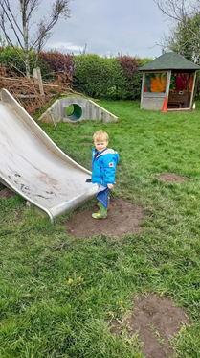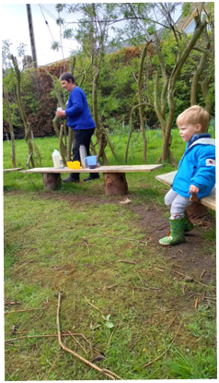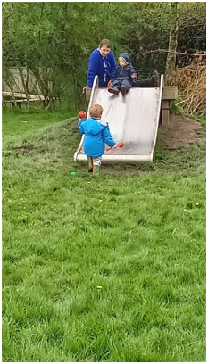

NHS HEIGHTS AND WEIGHTS PROGRAMME - RECEPTION CLASS:
Next Wednesday 11th May, the NHS Heights and Weights team will be coming to school to measure the Reception Class children. All Reception parents should have received a letter before half term which outlines the purpose of the programme and what to do if you do not wish your child to take part. The results are used anonymously to monitor children in Reception and then again in Y6. School does not receive any feedback regarding these results. If you are happy for your child to take part in this programme, you need not do anything further. If you do not wish your child to take part, please let the school office know.

TRANSITION INFORMATION:
Reception Class; Parents whose child has been offered a place in our Reception class for September will be receiving information today about the transition arrangements for their child.

THINGS TO DO:

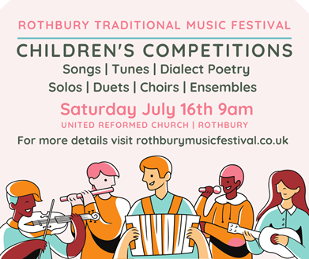Rothbury Traditional Music Festival has a long tradition of encouraging new and emerging talent and every year runs informal competitions for young musicians, vocalists and dialect poets. After the success of 2021’s online video competitions, we would love to invite your child or students to take part this year - our first in-person competitions since 2019! We are passionate about keeping traditional music and dialect poetry alive and the children’s competitions are open to all children aged 4-13, wherever you live and whatever your standard of playing. Absolute beginners are very welcome - these competitions are all about taking part and encouraging young performers to grow in their confidence and enjoyment of music and poetry in a friendly setting. The judges will give constructive feedback to each performer and there are prizes on offer for placed performers as well as a certificate of entry for every child.
The competitions are free to enter and there is no need to register in advance - just turn up on the day itself. If your child or students fancy joining in, come along to the United Reformed Church in the middle of Rothbury, behind the outdoor stage (tinyurl.com/rtmfkidscompslocation), between 9 and 9:30am on Saturday morning to sign up and warm up your instrument or voice. The competitions will start at approx 9:45 - with younger age groups performing first followed by the older groups - and run through to around 12:30 when the pipe band parade kicks off the main festival in the village. Children may enter more than one competition category (summary below). Please see tinyurl.com/rtmfkidscomps for detailed entry guidelines and rothburymusicfestival.co.uk for more general information about the festival. There will be a piano available in the venue for accompanists or performers to use.
Young performers aged 14 and over are encouraged to enter the novice categories of the adult competitions (also on Saturday and no pre-registration required) where they will receive a very warm welcome.
SUMMARY OF COMPETITION CATEGORIES
Solo Singing
Solo Instrument
Duet/Group Performance (Vocal, Instrumental or any combination thereof)
School Choirs First Schools (Reception to Y4); Middle (& Primary) Schools (Y5 to Y8)
Dialect Poetry
There are two age groups in each category: Ages 4-8 and Ages 9-13; except in Dialect Poetry where there is one Age 4-13 group.
Please see the entry guidelines for further detail: tinyurl.com/rtmfkidscomps
Families and children are very welcome at the whole festival and it is worth staying in the beautiful setting of Coquetdale after the competitions on Saturday for the free outdoor stage, street entertainment and face painter as well as ticketed concerts later in the day. Visit the festival website for further information about the programme and ticketed events (including a family-friendly ceilidh on Friday 15th) www.rothburymusicfestival.co.uk and keep an eye on our Facebook page for regular updates: www.facebook.com/musicfestival.rothbury
Buddha’s Birthday Sunday 15th May 12.00-4.00pm at the Oriental Museum
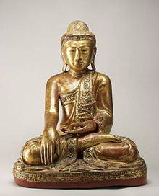Join us for an afternoon of relaxing guided meditation, a Buddhist-inspired chigiri-e paper collage workshop led by Japanese arts Noriko Matsubara, object handling and activities exploring Buddhist philosophy. Buddha’s Birthday (also known as Vesak) is celebrated around the world and commemorates the birth of the Buddha in around 563 BCE. Born a prince, Buddha went on to renounce his privileged royal life and become a holy man, ultimately reaching Enlightenment. The Museum will be decorated with paper cranes and lanterns and there will be a fun gallery trail and storytelling for children. Visitors will also be able to take part in Buddha Bathing and pour flower-scented water over a statue of the infant Buddha, symbolising the cleansing of body, speech and thoughts. All activities are FREE of charge and are suitable for all the family. We look forward to welcoming you to this special day. Book your free tickets via Eventbrite Contact: oriental.museum@durham.ac.uk
DIARY DATES
- Monday 9th May First lunchtime singing club with Mrs Barker
- Wednesday 11th May Reception class heights and weights check
- Thursday 12th May Y4 Ford Castle Residential Parents Meeting 4.30pm at Broomley Friday 27th May Platinum Jubilee Celebrations and Summer Fair
Friday 27th May School closes for Summer half term
- Monday 6th June School reopens for Summer term 2
- Tuesday 7th June Whole Class Photographs - Debbie Young Photography
- Wed 22nd - Fri 24th June Y4 Residential Trip to Ford Castle
- W/c 27th June Healthy Choices Week
- Thursday 7th July Sports’ Day - more details re: timings to follow soon
- Tuesday 12th July Y4 Corbridge Middle School transition day
- Wednesday 13th July Y4 Leavers’ Lunch and Leavers’ Assembly (2pm )
- Thursday 21 July School Closes for Summer holidays
- Friday 22nd July Additional holiday for Queen’s Platinum Jubilee
- Tuesday 6th September School Reopens for new school year

On behalf of staff and governors may I wish you all a lovely weekend.
Mrs Barker Executive Headteacher

