Communication and Language
- Compare and contrast stories that explore how we are special and unique and themes linked to topics, using related vocabulary.
- Follow instruction to make, construct and complete simple tasks.
Key Skills
- Extend vocabulary, especially by grouping and naming, exploring the meaning and sounds of new words.
- Respond to instructions involving a two-part sequence.
Personal, Social and Emotional
- Talking partners, show and tell, play situations working collaboratively with peers.
- Talking about what makes us special and unique. Exploring our talents and celebrate talents of famous people such as authors, historical figures, sports people.
Key Skills
- Confidence to talk about self in positive terms and talk about abilities.
- Confidence to share ideas and opinions with others.
Physical Development
- Music and movement sessions
- Tag rugby and large ball skills
- Construction – fine and gross motor skills.
- Drawing, letter formation and mark-making
Key Skills
- Experimenting with different ways of moving and travelling with skill.
- Form recognisable letters, most of which are correctly formed.
- Using tools and mark making materials with increasing accuracy.

Mathematics
Through play children will develop confidence to recognise numbers, count objects with increasing accuracy and start to represent number using fingers, objects and numeral writing. They will make comparisons between sets and start to make simple mental calculations and solve number problems practically.
Key Skills
- Use everyday language to talk about their day, exploring time, daily routines and sequencing events in time order.
- Find one more/less than a given number.
- Combining groups to find a total.

Key Skills

Literacy
- Explore features of information and story books on theme of animals and seasonal change.
- Rhyming pairs games, books and songs.
- Write labels, captions, simple sentences about characters and plot.
Key Skills
- Continue a rhyming string.
- Begin to read words and simple sentences.
- Write labels, captions, simple sentences.
- Enjoy an increasing range of books.

Creative Curriculum
Animals and Seasonal
Change
Autumn Term 2022: Reception
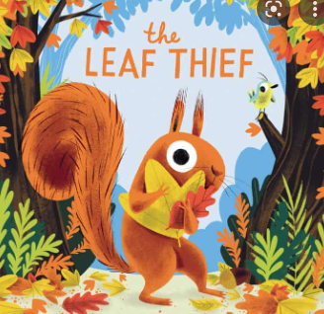

Understanding the world
Expressive Arts and Design
Key Skills
- Construct with a purpose in mind
- Begin to build a repertoire of songs and dances, singing simple songs, tapping a beat, moving to music
- Use a variety of art tools with increasing accuracy to create using a variety of medias.

Explore the world around us and how we are similar and
different in our likes, favourite things, appearance
Share news regularly about their own lives and experiences
Key Skills
- Talk about past and present events
- Talk about similarities and differences
between themselves and others.

