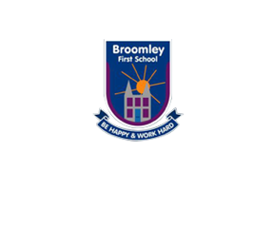T’

**Science Curriculum**

**Everyday Materials: Autumn 1 –Y1 / 2**

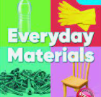 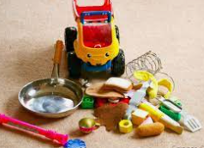

**Working Scientifically**

* Fit for Purpose? Explorify – cardboard shoes, chocolate tea pot, glass hammers- use reasoning skills
* Dressed for the Weather - Explorify– have a washing line or range of clothes in a washing basket. Identify suitability for different seasons
* Materials song <https://www.youtube.com/watch?v=xOKr462HLc0>
* Feely bag
* Sorting hoops
* Links to stories – The Three Little Pigs – a home fit for the pigs. Hibernating animals – a home fit for a hedgehog!

**Key Skills**

* Sort and classify objects
* Asking relevant questions and use different types of scientific enquiries to answer them
* Setting up simple, practical enquiries
* Make predictions and systematic and careful observations
* Recording findings language and drawings

**Key Vocabulary->**

|  |
| --- |
| Materials, wood, plastic, glass, metal, water, rock, fabric, rock, object, common, same, describe,  properties, hard, soft, stretchy, stiff, shiny, dull, rough, smooth, bendy, rigid, waterproof,  not waterproof, absorbent, not absorbent, opaque, transparent, test, record, investigation, prediction,  predict, watch, test, record, sensible, results, decision, sort, group, compare |

|  |
| --- |
|  |

**Creative Curriculum: Toys**

* Children sort different toys according to their properties
* Children receive a letter from a toy manufacturer asking them to design a new outdoor toy/bath toy – what properties does the toy need to have so it is ‘fit for purpose’

**Key Skills:**

* Identify and name different materials
* Group according to material/properties
* Make predictions
* Set up a simple, practical enquiry

**Content Knowledge**

* Identify and name a variety of different materials e.g. wood, plastic, glass, metal
* Distinguish between an object and the material it is made from
* Describe properties of materials through testing
* Find suitable materials for a purpose

**Key Skills**

* Observe and test the properties of materials
* Sort and classify different objects according to their properties

**Science Topic Enrichment**

**Outdoor learning**: Problem Solving – Explorify activity. Children have a selection of materials and work in groups are posed with a problem ‘to make a bird feeder that can withstand the weight of a small bird using just the materials provided’. Children need to make predictions about suitable materials and then out their creations to the test. MATERIALS SCAVENGER HUNT!

.