

**Creative Curriculum**

**World Study**

**Autumn: Year 3/ 4**

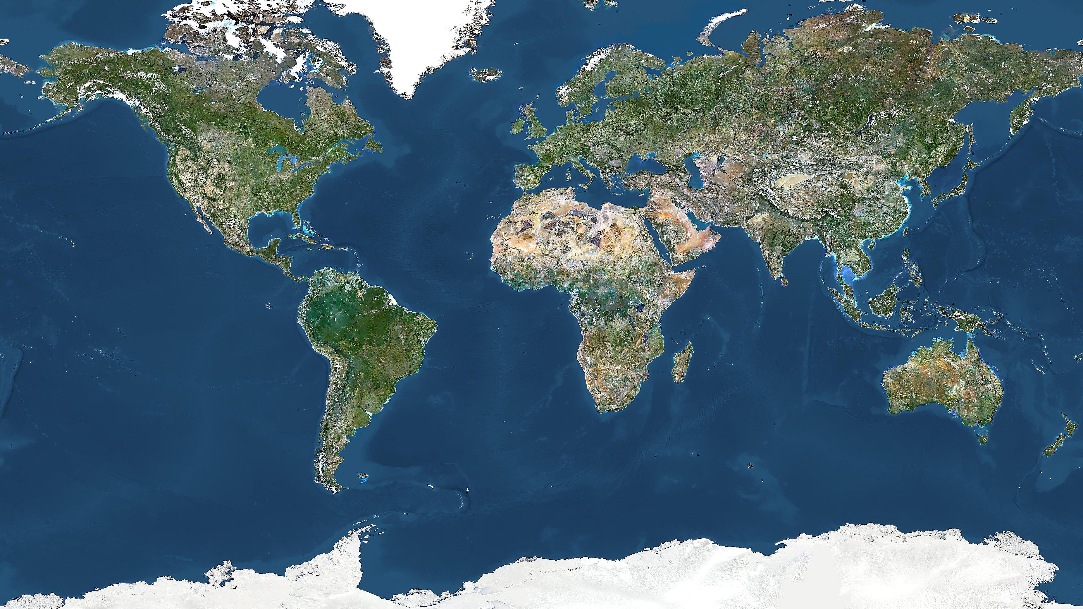

**Special Events / Visits**

**Geography**

Study different zones around the world, both physical and human. Identify key places from a different place on Earth find out about its geography.

**Key Skills**

* develop contextual knowledge of the location of globally significant places – both terrestrial and marine.
* develop their understanding, recognising and identifying key physical and human geographical features.
* use maps, atlases, globes and digital/computer mapping to locate countries and describe features studied

**Science**

Find out about light! What is it? Where does it comes from? Carry out tests to discover how shadows are altered as the light changes and how reflected light behaves when it comes off different surfaces. Explore what happens to light as it passes through a lens.

**Key Skills**

* recognise that they need light in order to see things and that dark is the absence of light
* notice that light is reflected from surfaces
* recognise that light from the sun can be dangerous and that there are ways to protect their eyes
* recognise that shadows are formed when the light from a light source is blocked by an opaque object
* find patterns in the way that the size of shadows change

**Art and DT**

Design and make art inspired by the art found in the place chosen for the Geography study (as chosen by the children). Study how Paul Gauguin was influenced by his travels to the Pacific Islands. Use paints to recreate his style.

* **Key Skills**
* **Improve mastery of techniques such as drawing, painting and sculpture.**
* **Use research and criteria to develop products which are fit for purpose.**
* **Evaluate existing products and improve own work**

**MFL**

* listen attentively to spoken language and show understanding by joining in and responding
* engage in conversations; ask and answer questions; express opinions and respond to those of others; seek clarification and help

**Music**

* play and perform in solo and ensemble contexts, using their voices and playing musical instruments with increasing accuracy, fluency, control and expression

**Outdoor Learning**

* I know what potential risks can be produced from different weather conditions.
* I know what type of fauna to expect to find in different habitats.
* I know what can and cannot be eaten
* I know some different uses of flora and fauna e.g. dyes, ropes, construction etc
* I know what to touch and what not to touch.

**Computing**

Develop a project for presentation using the programmes the children have already experienced. Use the internet browser to locate information and Powerpoint, word processor, desktop publisher or paint programme to support a presentation to the class.

**Key Skills**

* select, use and combine a variety of software to design and create a presentation
* import and export images from other software